Andrei, Alexandru-Nicusor | VMware Service Partner Meeting | April 4, 2018

vApps

using VMware



# vApps overview

A vApp is a preconfigured virtual machine that packages applications and parameters that define operational details. A vApp packages applications with their required operating systems.

A vApp allows disparate virtual machines to work together in a stack as an application and supports cloud-computing architectures. You can nest vApps within vApps, set up VMware resource pools, and deploy new vApps based on existing ones. VMware vApps operate on the Open Virtualization Format (OVF) standard and vApps are exported in OVF format.

Virtual Private Cloud OnDemand displays information about the vApp that contains each virtual machine; however, you do not select or manage vApps when you create a virtual machine in Virtual Private Cloud OnDemand. You manage vApps by using vCloud Director.

### Details: Differences Between vApps and Virtual Appliances

A virtual appliance is a generic term for an application delivered as a prebuilt unit. More specifically, a virtual appliance is a virtual machine image file consisting of a pre-configured operating system environment and a single application. The purpose of a virtual appliance is to simplify delivery and operation of an application. To this end, only necessary operating system components are included.

A virtual appliance can be deployed as a virtual machine or a subset of a virtual machine running on virtualization technology, such as VMware Workstation. Deploying an application as a virtual appliance can eliminate problems with installation and configuration, such as software or driver compatibility issues.

“vApp” is a VMware specific term for an application encapsulated within a vApp pool (which works in a hosted environment and on hypervisors). A vApp can define several specific things about an appliance, such as performance and resource pools, IP address allocation policies, or firewall requirements.

# Managing Virtual Machines with a vApp

You can use vSphere as a platform for running applications, such as multitiered applications. The applications can be packaged to run directly on top of vSphere.

In vSphere Web Client, a vApp is represented in the Hosts and Clusters view and in the VM and Templates view.

A vApp is a container for one or more virtual machines or vApps. A vApp shares functionality with virtual machines. A vApp can power on and power off and it can be cloned. The distribution format for a vApp can be either Open Virtualization Format (OVF) or Open Virtualization Appliance (OVA). The differences between these formats are:

• An OVF file is a collection of virtual machine files. The OVF file is an XML file that has information about the virtual disk files in the directory. When you export a virtual machine as an OVF file, a directory is created that has an OVF file and the VMDKs.

• OVA is the portable virtual machine format from XenSource, a third-party product. The OVA file is a single file that can considered an archive, like a ZIP file, of all the files that belong to the OVF directory.

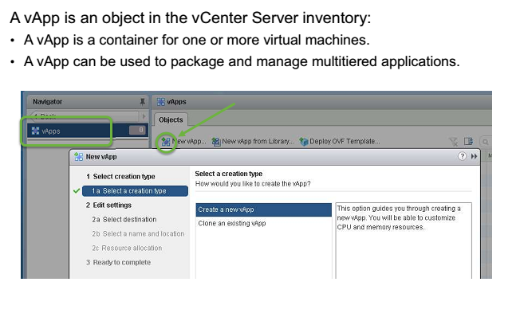

# vApp Characteristics

After creating the vApp, you can modify certain vApp settings:

* Resource allocation: Determines how CPU and memory should be allocated for the vApp.
* IP allocation policy: Determines how IP addresses are allocated for the vApp.
* Advanced settings: Product and vendor information, and custom properties.

You can change the order in which virtual machines (and nested vApps) in a vApp start up and shut down. You change this order by assigning virtual machines to groups. All entities in the same group are started before those in the next group. Shutdown is done in the reverse order. You can also specify delays and actions performed at startup and shutdown.

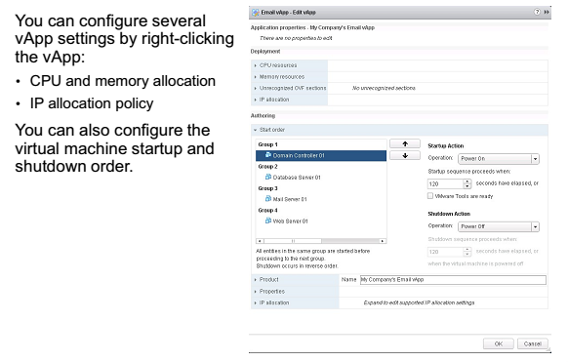

# Exporting and Deploying vApps

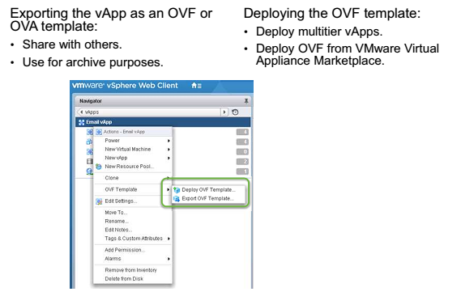

# Managing vApps

## Create a vapp

1. On the Web Client Home page, select **Global Inventory Lists**
2. Select **vApps** from the Navigator pane.
3. Click the **Create a New vApp** icon.

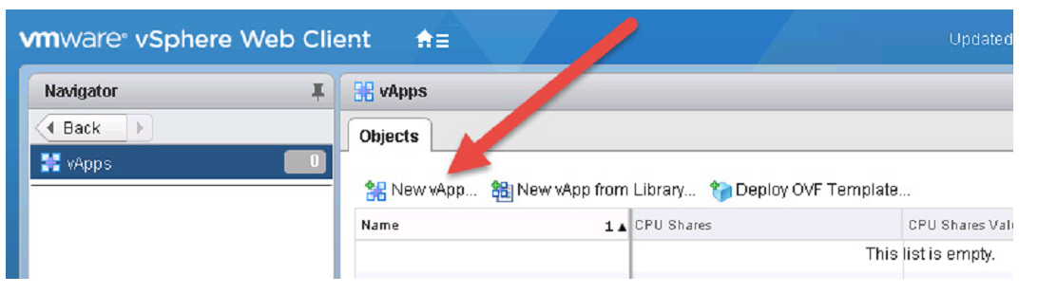

1. Follow the New vApp wizard

